

Safety Bay Senior High School
Chemistry Unit 1 & 2

Assignment #1:
Validation Test

NAME: ______________________________________

Reading time: 5 minutes
Working time: 55 minutes

Section | Mark
Written assignment | / 24
Validation test  (= Test score x2) | / 76
Total | / 100

- (5 marks)

- Draw a labelled diagram of an atomic absorption spectrophotometer showing the burner, detector, hollow cathode lamp and monochromator and slit. (1 mark)

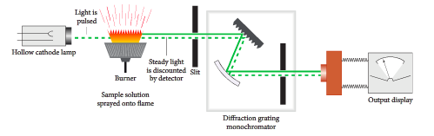
Detector

Answer | Marks
All pieces in correct order. (Diagram does not need to be as detailed as above image) | 1 mark
Award half mark if all in correct order except for one piece | -
Total marks: | 1 mark

- Describe the role of the hollow cathode lamp in atomic absorption spectroscopy. (2 marks)

Answer | Marks
Hollow cathode lamp is made of same element being analysed | 1 mark
Emits wavelengths of light characteristic to that element | 1 mark
Total marks: | 2 marks

- What is the function of the monochromator? (1 mark)

Answer | Marks
Selects one wavelength of light to be analysed | 1 mark
Total marks: | 1 mark

- What is the function of the detector? (1 mark)

Answer | Marks
Measures intensity of light / Measures absorbance / Changes light into electrical signals | 1 mark
Total marks: | 1 mark

- (5 marks)

- Explain what the term absorption refers to in the term “atomic absorption spectroscopy” and include a diagram to help illustrate your answer. (2 marks)

Answer | Marks
Electrons absorb energy and get excited to a higher energy level | 1 mark
Suitable diagram showing absorption included:  e.g. 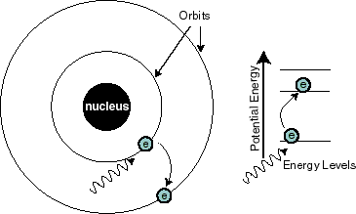 | 1 mark
Do not accept explanations or diagrams which show emission instead of absorption | -
Total marks: | 2 marks

- Describe the relationship between absorbance and concentration of an element in a sample.
(1 mark)

Answer | Marks
As concentration increases so will absorbance | 1 mark
Total marks: | 1 mark

- Chalcopyrite is a mineral containing copper, iron and sulfur. Would the presence of iron in the sample affect the instrument’s ability to detect copper? Explain your answer. (2 marks)

Answer | Marks
No it will not. Iron will not absorb the same wavelengths that copper will... | 1 mark
...because the wavelength absorbed depends on the differences between energy levels in the atom and iron has a different electron configuration to copper | 1 mark
Total marks: | 2 marks

- (8 marks)

A chemist wished to analyse the amount of zinc in dietary supplement tablets. They prepared 4 tablet samples for analysis by dissolving the tablets individually in 10% nitric acid. Each tablet solution was made up to a final volume of 100 mL. Five standard solutions of zinc were also prepared. The absorbances of the standard and sample solutions were determined by atomic absorption spectroscopy of 213.9 nm, and the results are shown in the table below.

Standard zinc solutions (mg L⁻¹) | Absorbance
0.00 | 0.000
1.00 | 0.170
2.00 | 0.330
3.00 | 0.503
4.00 | 0.680
Tablet samples: mean absorbance | 0.280

- Plot a calibration curve for the standard zinc solutions on the grid below. (5 marks)

Answer | Marks
Y axis label: “Absorbance” | 1 mark
X axis label: “Concentration of zinc (mg/L)” NOT: “Standard zinc solutions” | 1 mark
Scales on axes go up in regular intervals and make use of available graph space | 1 mark
Points are plotted accurately | 1 mark
A linear line of best fit is plotted | 1 mark
Total marks: | 5 marks

- Use your calibration curve and the mean absorbance for the tablet samples to calculate the mean amount of zinc per tablet in mg. (3 marks)

Answer | Marks
Draws lines of graph matching absorbance to concentration for tablet samples | 1 mark
Concentration ≈ 1.7 mg/L | 1 mark
(Each tablet was dissolved in 0.1 L therefore)  m(Zn) = 1.7 mg/L x 0.1 L = 0.17 mg | 1 mark
Total marks: | 3 marks

- (4 marks)

Gas chromatograms are instruments which are able to separate compounds from a mixture. A diagram of a gas chromatogram is shown below:

- Name the part labelled X on the diagram. (1 mark)

Answer | Marks
Column | 1 mark
Total marks: | 1 mark

- Name the part labelled Y on the diagram. (1 mark)

Answer | Marks
Oven | 1 mark
Total marks: | 1 mark

- Why do substances become separated when they move through the part labelled X. (2 marks)

Answer | Marks
Separation is based on:
- Molecular size  - (Elaboration:) Smaller substances/more volatile substance move through the column more readily than larger substance/less volatile substances) | 0.5 marks  0.5 marks
- Attraction to stationary phase  - (Elaboration:) Particles that adsorb onto the stationary phase readily take a long time to move through column than particles that do not | 0.5 marks  0.5 marks
Total marks: | 2 marks

- (4 marks)

An athlete provided a urine sample to be tested for steroids. The sample and the steroid standards were treated and then analysed by gas chromatography with mass spectrometric detection.

Below are the chromatograms of a standard mixture containing four different steroids, and the sample from the athlete.

- Which steroid has the athlete taken? Justify your answer. (2 marks)

Answer | Marks
Stanozolol | 1 mark
Both spectra show a matching peak at 5 minutes  (justification should include elution time) | 1 mark
Total marks: | 2 marks

- It is possible for two different compounds to have the same retention time during gas chromatography, thus gas chromatographs would not conclusively prove in court whether or not the athlete has taken a type of steroid. How could a forensic scientist use mass spectrometry to confirm whether or not the steroid is present in the urine sample? (2 marks)

Answer | Marks
Test a known sample of stanozolol using mass spectrometry and then compare the mass spectrum pattern of the unknown substance to the reference sample | 1-2 marks
Award 1 mark for an answer which shows an understanding of how mass spectrometry works but doesn’t fully explain the need to compare to a known reference sample. Even if not covered in their assignment they should understand this concept from reading Question 6. | -
Total marks: | 2 marks

- (2 marks)

An unknown sample was collected and was analysed by mass spectrometry. The mass spectrum of the substance is shown below:
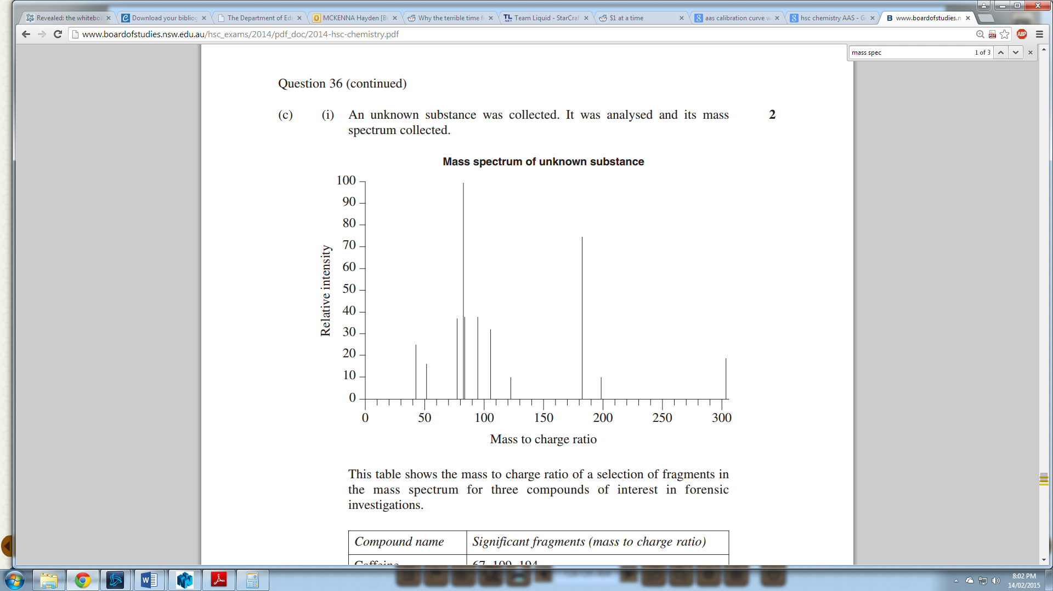

This table shows the mass to charge ratio of a selection of fragments in the mass spectrum for three compounds of interest in forensic investigations.

Compound name | Significant fragments  (mass to charge ratio)
Caffiene | 67 109 194
Cocaine | 82 94 182
Paracetemol | 43 109 151

What is the identity of the unknown substance? Justify your answer. (2 marks)

Answer | Marks
Cocaine | 1 mark
The substance has major peaks with mass to charge ratios of approx. 82, 94, and 182  /  The mass spectrum of the unknown sample has major peaks that match the significant fragments of cocaine | 1 mark
Total marks: | 2 marks

- (5 marks)

A pure, gaseous sample of element Z is introduced into a mass spectrometer, and the spectrum below is generated:

- What do the peaks in this spectrum represent? (1 marks)

Answer | Marks
The relative abundance of different isotopes of the element / The relative abundance of atoms with different atomic masses | 1 mark
Total marks: | 1 mark

- Use the graph to calculate the average atomic mass of element Z. (2 marks)

Answer | Marks
$$Ar= \frac{\left(82×15\right)+\left(83×15\right)+\left(84×60\right)+\left(86×10\right)}{100} \\ =83.75$$ | 1-2 marks
Total marks: | 2 marks

- Using your periodic table, identify and name element Z. (1 mark)

Answer | Marks
Krypton | 1 mark
Total marks: | 1 mark

- Write the formula of the major isotope of this element in the form of ${}_{Z}^{A}X$. (1 mark)

Answer | Marks
$${}_{36}^{84}{Kr}$$ | 1 mark
Total marks: | 1 mark
- (5 marks)

- List and briefly outline the four main steps that occur inside a mass spectrometer during the process of mass spectrometry. (4 marks)

Answer | Marks
- Ionisation: Electrons are removed from atoms to form positive ions | 1 mark
- Acceleration: Ions are accelerated into electric field | 1 mark
- Deflection: Ions are deflected by an electromagnet | 1 mark
- Detection: Beam of ions detected | 1 mark
Total marks: | 4 marks

- Draw a labelled diagram of a mass spectrometer showing the main parts of the instrument. (1 mark)

Answer | Marks
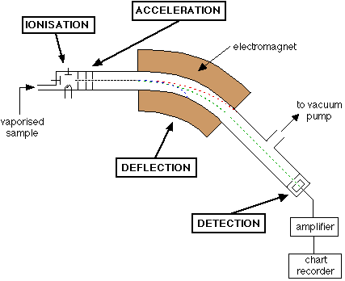 | 1 mark
Total marks: | 1 mark

